QA Testing Engineer Profile Test (Behave, Selenium, SQL, Python, testing knowledge)

This test was built in 3 parts, a functional one with requirement analysis, automation, SQL Databases basics and some questions about software testing.

Part 1:

* With the following scenarios, automate the interaction. For this you should use whether version of the listed frameworks you like: Python and selenium.
  1. Scenario 1: User can search with “Google Search”
     + Given I’m on the homepage
     + When I type “test automation” into the search field And I click the Google Search button
     + Then I go to the search results page, and the first 3 results contain the word “automation”
  2. Scenario 2: User can go to the first search result
     + Given I Search by keyword
     + When I click on the first result link
     + Then I go to the page, and the page title contains the word “automation”

<https://github.com/davidorozcoh/googlesearch>

Guidelines:

You are testing https://www.google.com.

Always make use good principles and practices when designing your Solution.

Implement your automation solution, if possible, following the Page Object Model pattern and BDD paradigm.

Part 2 (SQL Basic Scripting):

1. Explain the difference, in databases, between ‘Having’ and ‘where’ when it comes to a query. Develop one example for each one of this two cases and point out the difference.

**WHERE** The WHERE allows queries to be made on the registers, which can be queried by segments, a condition is applied to the result of the row

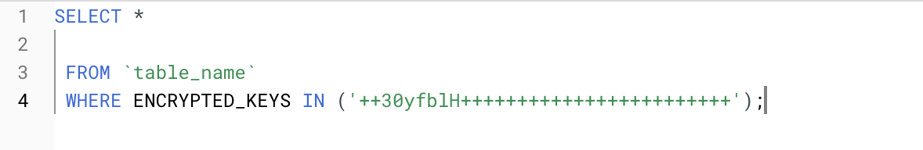

The name of the table and the condition that would be the where we bring what we want to filter is indicated

**HAVING** The HAVING we can say that it applies the same condition that is done with the WHERE but grouped together

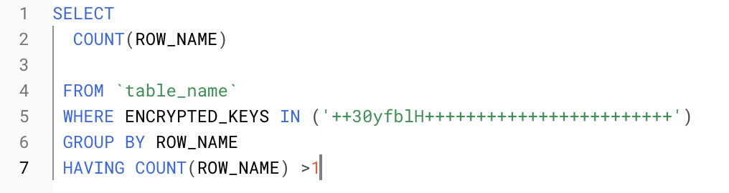

So for this example we validate the amount of duplicate data, for this we group by field to identify how many times the value is repeated

1. Write a query for create a data table ‘Student’ with the following attributes in it: ‘Name, ‘Code, ‘Class’, ‘Age’, ‘Favorite Subject, ‘GPA’ (5.0 scale).

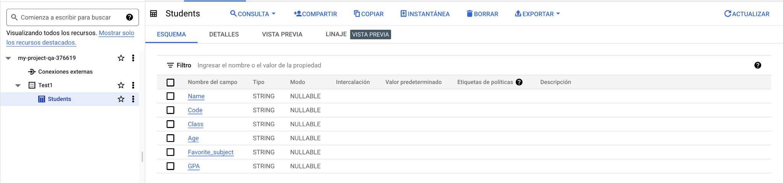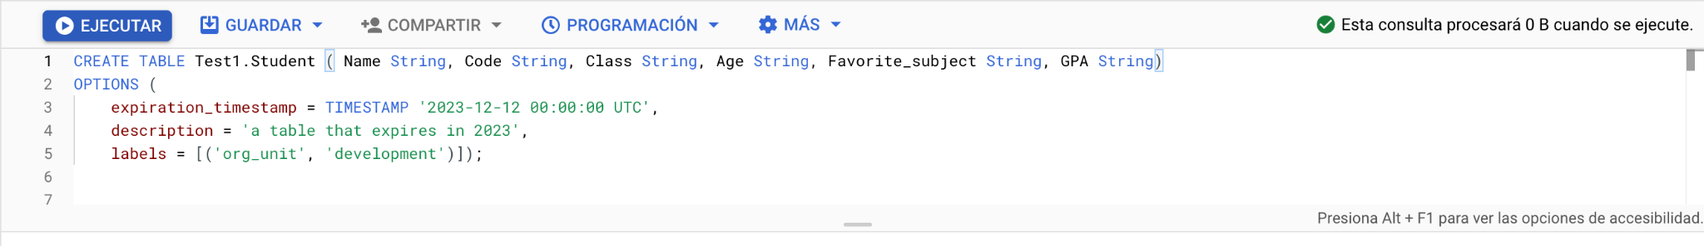

1. Insert at least 40 records in the last table with close to real data.
2. Write a query to get the average of the GPA from all the students which name starts with ‘A’.
3. Write a query to get the list of students that are in the same class, have a GPA higher than 3.5/5.0 and order them by Age and Name.
4. Write a query to get the list of all the students with ‘Name, ‘Code, ‘Class’, ‘Age’, ‘Favorite Subject, ‘GPA’.

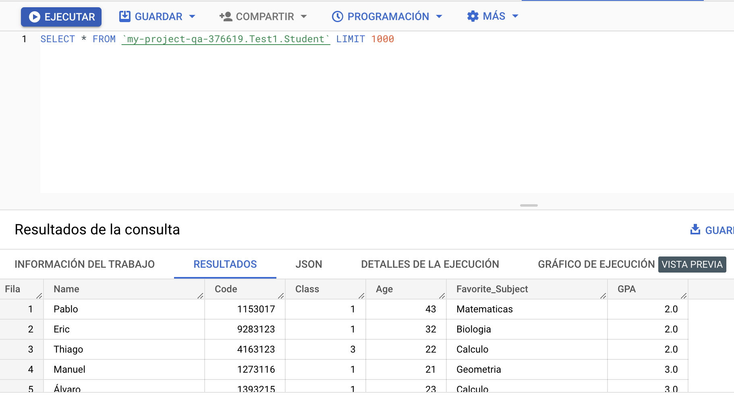

1. Take the following 25 question quiz about SQL, please include a screenshot about the results and time it took to take the test.

<http://www.w3schools.com/quiztest/quiztest.asp?qtest=SQL>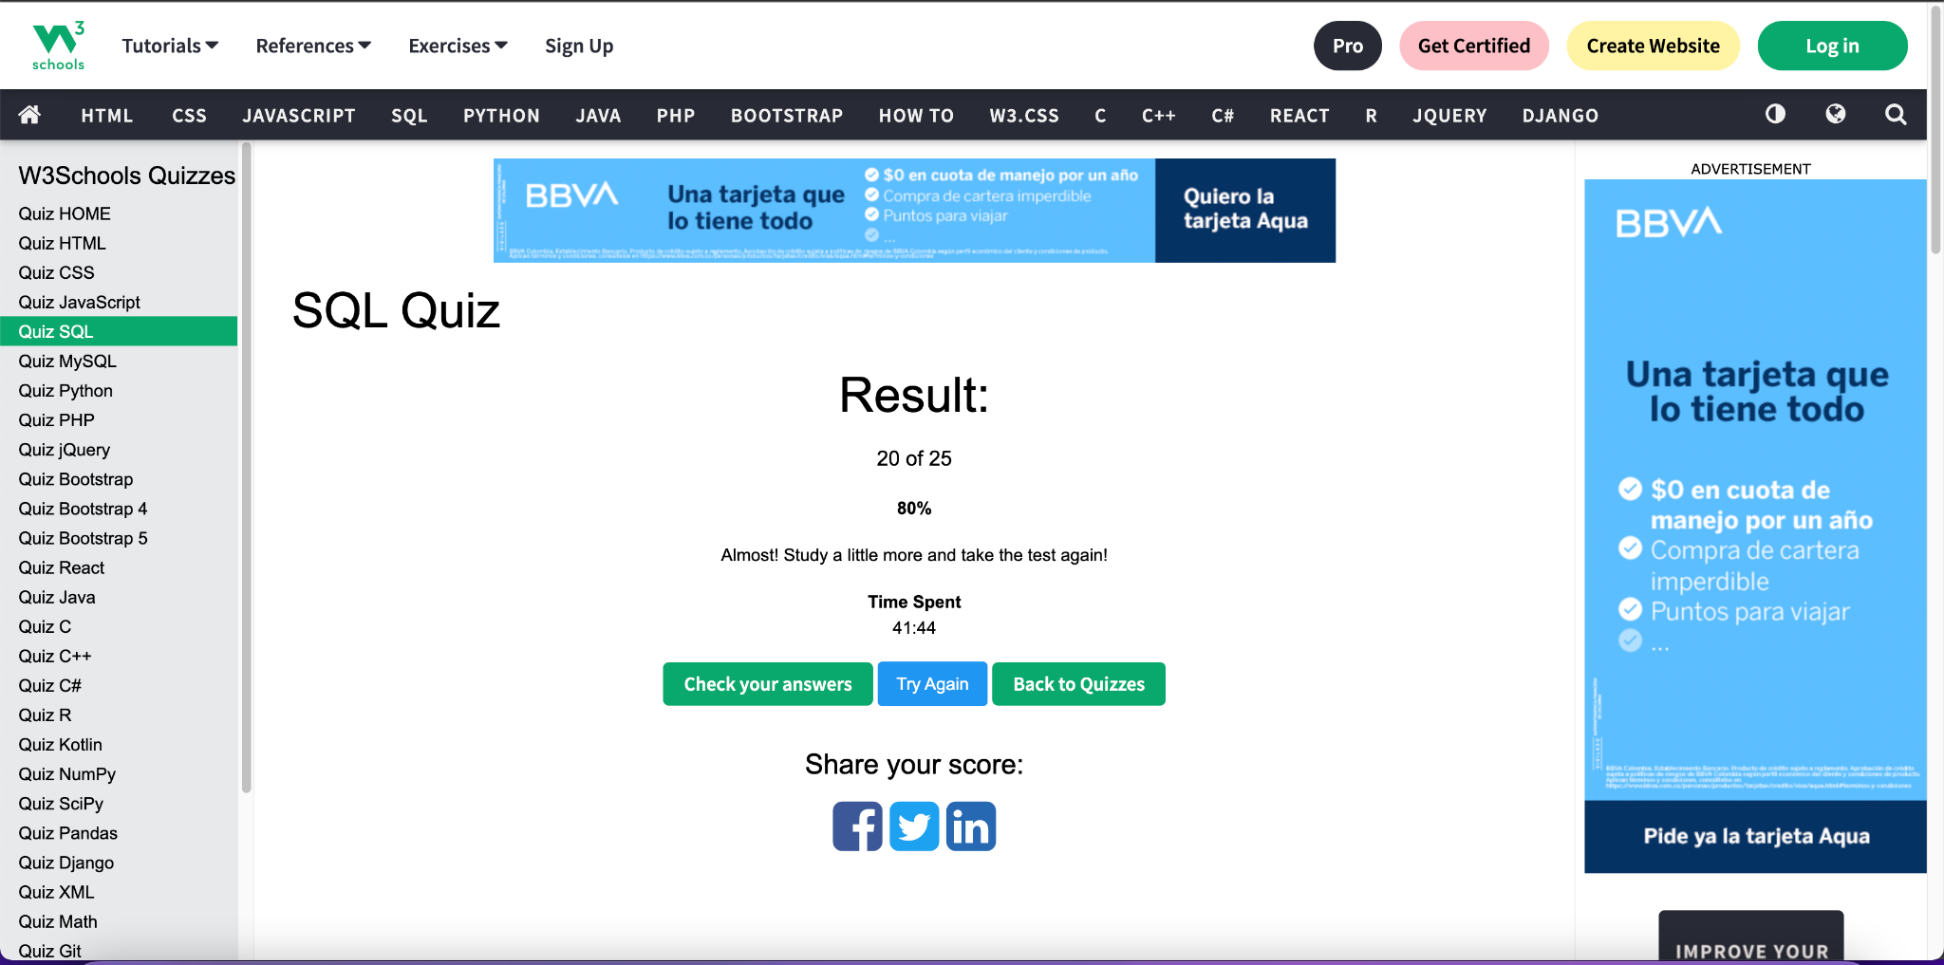

Part 3 (Software Testing Knowledge):

1. What is the difference between a unit test, an acceptance test, an integration test and an end-to-end test?

**Unit test** are the tests that are executed when the development is in its first stage, usually run by the developer.

**Integration test** are generally those that are executed to test the different modules of the application, that these function correctly, there you can detect possible errors.

**Acceptance test** are tests that are performed to validate the correct functioning of the application and that its functionality meets the established requirements.

**End-to-end test** these are tests that are generally performed from start to finish validating that the established parameters are being met, these tests are performed on the entire application

1. Could you explain Cohn's automation pyramid?

It is the one that allows to implement agile methodologies at the time of testing, this mostly saves time in each execution and also allows the testing process to be more organized

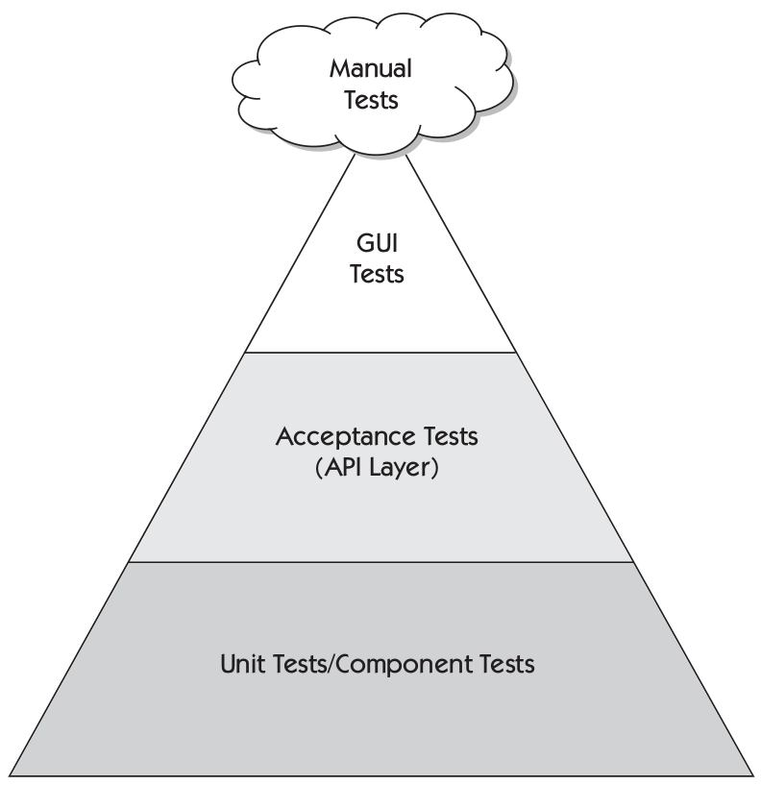

1. Could you explain the difference between a black box testing and a white box testing?

**White box** these tests are used to perform validations on the code and the type of structure used

**Black box** these tests are used to perform validations of the graphical interface of the application validating that it works correctly, usually only for the graphical interface

1. What is the purpose of an exploratory test and when is it useful to run them?

It is used to have a better view of the product by investigating in depth the operation of the application.

1. Mention at least 5 test design techniques and explain them briefly

**Stress tests** are tests that measure the performance of the system

**Smoke tests** are tests that allow to measure developmental functioning in depth

**Regression tests** are tests that are performed after integrating the development, to validate that the application is working properly after a change

**Load tests** are performance tests of the software to ensure its proper functioning before its massive execution

**System tests** are tests that are performed on the system in greater depth to verify its good performance

1. What is the purpose of the following types of tests?
   1. Functional test: allows to assure the correct operation of the system
   2. Performance test: allows to evaluate that the execution times are adequate according to your requirements
   3. Security test: allows to evaluate the security for system access by validating that only authorized users can access the system
   4. Usability test: allows to validate the quality of the software in its usability that it is easy to use and that it allows the end user to interact easily
   5. API test: tests are performed at the backend level where we can validate that the different functional blocks perform their expected function
   6. Unit Test: are the tests that are executed when the development is in its first stage, usually run by the developer.

References:

* <https://www.softwaretestinghelp.com/the-difference-between-unit-integration-and-functional-testing/>
* <https://stackoverflow.com/questions/7672511/unit-test-integration-test-regression-test-acceptance-test>
* <https://www.softwaretestinghelp.com/what-is-end-to-end-testing/>
* <https://www.testingexcellence.com/exploratory-testing-important-agile-projects/>
* <https://www.guru99.com/exploratory-testing.html>
* <http://softwaretestingfundamentals.com/differences-between-black-box-testing-and-white-box-testing/>
* <https://smartbear.com/solutions/api-testing/>
* <http://softwaretestingfundamentals.com/security-testing/>
* <https://www.guru99.com/what-is-security-testing.html>
* <https://www.experienceux.co.uk/faqs/what-is-usability-testing/>
* <https://en.wikipedia.org/wiki/API_testing>
* <https://en.wikipedia.org/wiki/Application_programming_interface>
* <https://searchsoftwarequality.techtarget.com/definition/performance-testing>
* <https://www.guru99.com/performance-testing.html>
* <https://www.tutorialselenium.com/2017/05/28/como-usar-selenium-ide/>
* <https://cleventy.com/tutorial-selenium-primeros-pasos/>
* <http://www.juntadeandalucia.es/servicios/madeja/contenido/recurso/381>
* <https://www.tutorialselenium.com/2017/09/24/como-usar-comandos-de-selenium-ide/>
* <https://testeandosoftware.com/selenium-comandos-selenese/>
* <https://www.seleniumhq.org/selenium-ide/docs/en/introduction/getting-started/>
* <http://www.cs.tau.ac.il/~amiramy/SoftwareSeminar/CTDmay2012.PDF>
* <https://www.guru99.com/decision-table-testing.html>
* <https://www.toolsqa.com/software-testing/decision-table-testing/>
* <https://www.tutorialspoint.com/software_testing_dictionary/data_flow_testing.htm>
* <https://www.javatpoint.com/data-flow-testing-in-white-box-testing>
* <https://www.thedigitalmentor.com/what-is-dataflow-testing/>
* <https://en.wikipedia.org/wiki/Boundary-value_analysis>
* <https://www.guru99.com/equivalence-partitioning-boundary-value-analysis.html>
* <https://www.testingexcellence.com/boundary-value-analysis/>
* <http://www.professionalqa.com/combinatorial-testing>
* <https://en.wikipedia.org/wiki/Classification_Tree_Method>
* <https://www.expleo-germany.com/en/products/testona/classification-tree-method/>
* <https://inf.mit.bme.hu/sites/default/files/materials/taxonomy/term/445/13/04_Testing.pdf>
* <https://www.bcs.org/upload/pdf/amettehass-131211b.pdf>
* <https://www.bcs.org/upload/pdf/amettehass-131211a.pdf>
* <https://www.tutorialspoint.com/software_testing_dictionary/pdf/test_case_design_technique.pdf>
* <https://testautomationresources.com/software-testing-basics/software-test-design-techniques/>
* <https://www.uio.no/studier/emner/matnat/ifi/INF3121/v18/forelesningsvideoer/chapte-4-part-2-slides.pdf>
* <http://tryqa.com/what-is-test-design-technique/>
* <http://tryqa.com/what-is-structure-based-technique-in-software-testing/>
* <http://tryqa.com/what-is-black-box-specification-based-also-known-as-behavioral-testing-techniques/>
* <http://tryqa.com/what-is-white-box-or-structure-based-or-structural-testing-techniques/>